Cameron Jewell Garrett Crowder

9/21/17

SM&D

Course Project Iteration 1 Data Flow

1. General

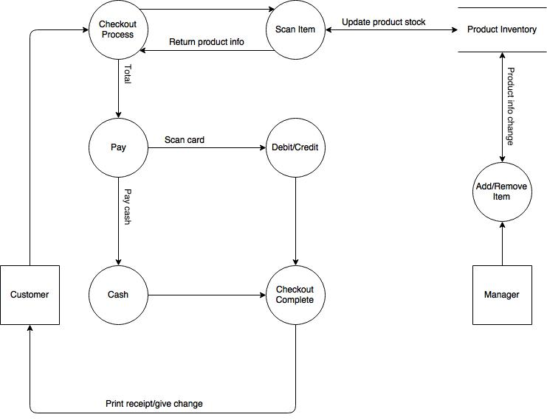

Specific Use Case Data Flow Diagrams

* As a user, I want to check out an order in store for a customer.

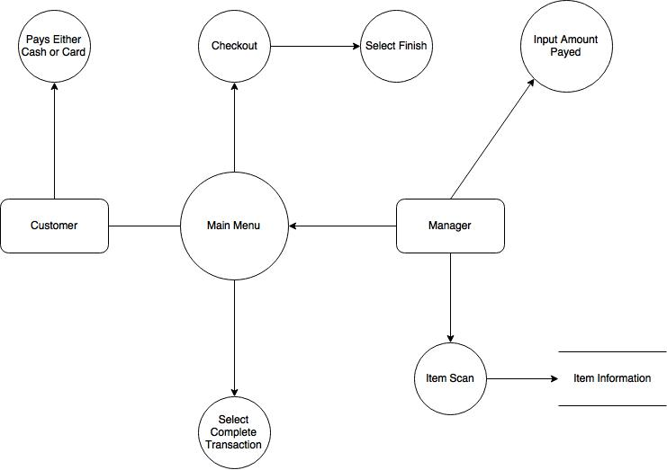

* As a user, I want to add a new product into the system.

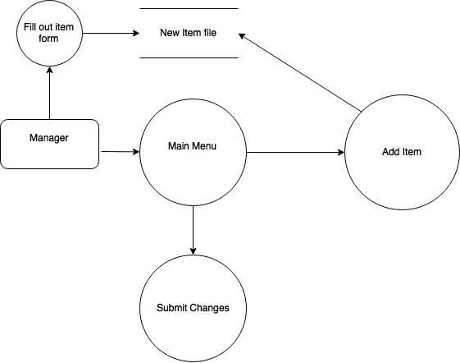

* As a user, I want to update the product information.

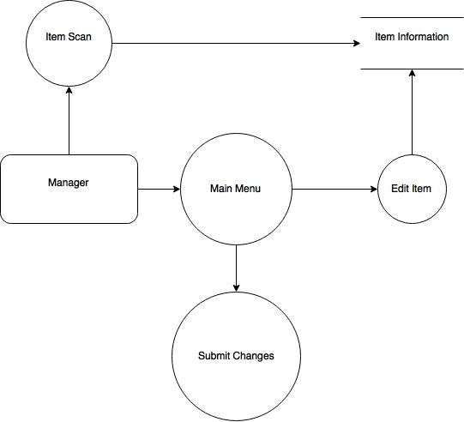

1. Entity Relationship Diagram

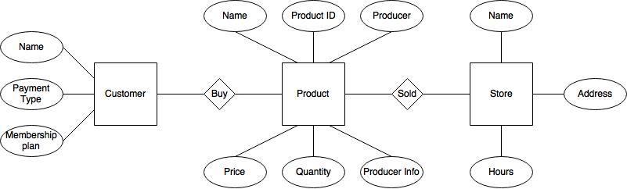

1. Sample Dataset (5 customers, 5 items each)

Customer 1 – pays with cash – change back: $4.00

|  |  |  |
| --- | --- | --- |
| **Item** | **Price** | **Quantity** |
| Toilet Paper | $3 | 2 |
| Apple | $2 | 4 |
| Grapefruit | $3 | 5 |
| Pens | $5 | 1 |
| Sunflower Seeds | $2 | 1 |
| **Total** | **$ 36.00** |  |

Customer 2 – pays with credit card

|  |  |  |
| --- | --- | --- |
| **Item** | **Price** | **Quantity** |
| Bottled Water | $4 | 2 |
| Cheese | $3 | 1 |
| Charcoal | $7 | 1 |
| Ground Beef | $5 | 2 |
| Buns | $2 | 2 |
| **Total** | **$ 32.00** |  |

Customer 3 – pays with debit card

|  |  |  |
| --- | --- | --- |
| **Item** | **Price** | **Quantity** |
| Beer | $9 | 3 |
| Bread | $3 | 1 |
| Butter | $5 | 1 |
| Ice Cream | $4 | 2 |
| Yogurt | $4 | 4 |
| **Total** | **$ 59.00** |  |

Customer 4 – pays with check

|  |  |  |
| --- | --- | --- |
| **Item** | **Price** | **Quantity** |
| Orange | $3 | 3 |
| Lemons | $2 | 7 |
| Limes | $2 | 6 |
| Milk | $3 | 1 |
| Eggs | $4 | 1 |
| **Total** | **$ 42.00** |  |

Customer 5 – pays with food stamps

|  |  |  |
| --- | --- | --- |
| **Item** | **Price** | **Quantity** |
| Wine | $12 | 2 |
| Frozen Pizza | $5 | 1 |
| Chocolate | $4 | 3 |
| Tissues | $5 | 2 |
| Eye drops | $5 | 1 |
| **Total** | **$ 56.00** |  |